**Aim: WAP in Tinkercad to develop earthquake detector using tilt sensor, LCD, Buzzer and Arduino Uno**

**Theory:**

·        **Tilt Sensor**

Tilt sensors are devices that produce an electrical signal that varies with an angular movement. These sensors are used to measure slope and tilt within a limited range of motion. Sometimes, the tilt sensors are referred to as inclinometers because the sensors just generate a signal but inclinometers generate both readout and a signal.

These sensors consist of a rolling ball with a conductive plate beneath them. When the sensor gets power, the rolling ball falls to the bottom of the sensor to form an electrical connection. When the sensor is tilted, the rolling ball doesn’t fall to the bottom so that the current cannot flow the two end terminals of the sensor.

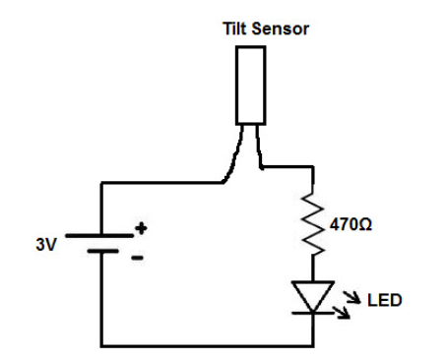

·        **Arduino Uno**

Arduino is an open-source electronics platform based on easy-to-use hardware and software. [Arduino boards](https://www.arduino.cc/en/Main/Products) are able to read inputs - light on a sensor, a finger on a button, or a Twitter message - and turn it into an output - activating a motor, turning on an LED, publishing something online. You can tell your board what to do by sending a set of instructions to the microcontroller on the board. To do so you use the [Arduino programming language](https://www.arduino.cc/en/Reference/HomePage) (based on [Wiring](http://wiring.org.co/)), and [the Arduino Software (IDE)](https://www.arduino.cc/en/Main/Software), based on [Processing](https://processing.org/).

·        **Buzzer**

A Buzzer is basically a tiny speaker that you can connect directly to an Arduino. From the arduino, you can make sounds with a buzzer by using tone. You have to tell it which pin the buzzer is on, what frequency (in Hertz, Hz) you want, and how long (in milliseconds) you want it to keep making the tone.

**Circuit Diagram:**

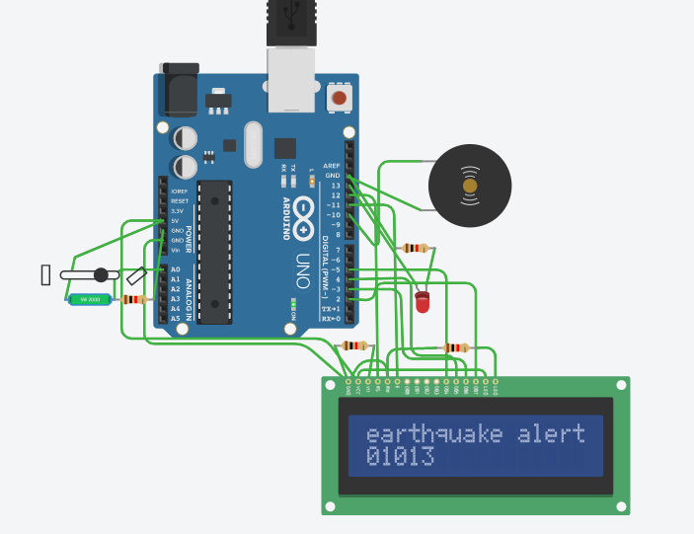

**Code:**

#include<LiquidCrystal.h>

#define buzzer 10

#define led 13

#define o A0

#define samples 50

#define maxVal 10

#define minVal -10

#define buzTime 5000

LiquidCrystal lcd(12,11,5,4,3,2);

int osample=0;

long start;

int buz=0;

void setup()

{

lcd.begin(16,2);

Serial.begin(9600);

delay(1000);

lcd.print("earthquake");

lcd.setCursor(0,1);

lcd.print("detector");

delay(2000);

lcd.clear();

lcd.setCursor(0,1);

lcd.print("Wait");

pinMode(buzzer, OUTPUT);

pinMode(led, OUTPUT);

buz=0;

digitalWrite(buzzer, buz);

digitalWrite(led, buz);

for(int i=0;i<samples;i++)

{

osample+=analogRead(o);

}

osample/=samples;

delay(3000);

lcd.clear();

lcd.clear();

lcd.print("ready");

delay(1000);

lcd.clear();

lcd.print("A");

}

void loop()

{

int value1=analogRead(o);

int ovalue=osample-value1;

lcd.setCursor(0,1);

lcd.print(ovalue);

delay(100);

if(ovalue < minVal || ovalue > maxVal)

{

if(buz == 0)

start=millis();

buz=1;

}

else if(buz == 1)

{

lcd.setCursor(0,0);

lcd.print("earthquake alert ");

if(millis()>= start+buzTime)

buz=0;

}

else

{

lcd.clear();

lcd.print("A");

}

digitalWrite(buzzer, buz);

digitalWrite(led, buz);

Serial.print("A=");

Serial.println(ovalue);

}